**KINDERGARTEN**

**Holiday homework for winter vacation**

**(2015-2016)**

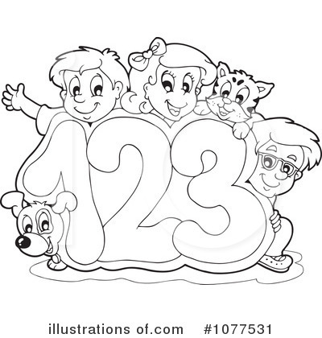

**DAV Public School**

Sector VI, Dwarka, New Delhi

Ref.no. \_\_\_\_\_\_\_\_\_\_\_\_\_\_\_\_\_\_\_\_\_\_\_\_\_ Date \_\_\_\_\_\_\_\_\_

**Subject- English**

Name \_\_\_\_\_\_\_\_\_\_\_\_\_\_\_\_\_\_\_\_\_\_\_\_\_ Class- Pre School\_\_\_\_

* See the picture and write the initial letters.

|  |  |
| --- | --- |
| Macintosh HD:Users:mac_osx:Desktop:shapes:images17.jpg |  |
| Macintosh HD:Users:mac_osx:Desktop:shapes:images10.png |  |
| Macintosh HD:Users:mac_osx:Desktop:shapes:images12.jpg |  |
| Macintosh HD:Users:mac_osx:Desktop:shapes:images11.png |  |

* Write the missing letters.

|  |  |  |  |  |
| --- | --- | --- | --- | --- |
| **a** |  | **c** |  | **e** |
|  | **g** |  | **i** |  |
| **k** |  | **m** |  | **o** |

* Draw 2 pictures of each alphabet.

|  |  |  |
| --- | --- | --- |
| b |  |  |
| n |  |  | |
| q |  |  | |

* Match the following.

|  |  |
| --- | --- |
|  | c  f  p    l |

* Write a-r

|  |  |  |  |  |
| --- | --- | --- | --- | --- |
|  |  |  |  |  |
|  |  |  |  |  |
|  |  |  |  |  |
|  |  |  |  |  |

**DAV Public School**

Sector VI,Dwarka,New Delhi

Ref.no. \_\_\_\_\_\_\_\_\_\_\_\_\_\_\_\_\_\_\_\_\_\_\_\_\_ Date \_\_\_\_\_\_\_\_\_

**Subject- Maths**

Name \_\_\_\_\_\_\_\_\_\_\_\_\_\_\_\_\_\_\_\_\_\_\_\_\_ Class- Pre School\_\_\_\_

Comparison : More –Less

Which group has more objects ? (encircle )

|  |  |  |
| --- | --- | --- |
| |  |  | | --- | --- | | Macintosh HD:Users:mac_osx:Desktop:shapes:images27.png | Macintosh HD:Users:mac_osx:Desktop:shapes:images27.pngMacintosh HD:Users:mac_osx:Desktop:shapes:images27.png | |

Which group has less objects ? (encircle )

|  |  |  |
| --- | --- | --- |
| |  |  | | --- | --- | | Macintosh HD:Users:mac_osx:Desktop:shapes:images31.png | Macintosh HD:Users:mac_osx:Desktop:shapes:images31.pngMacintosh HD:Users:mac_osx:Desktop:shapes:images31.png | |

Match the shapes to the correct objects .

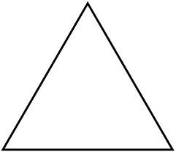

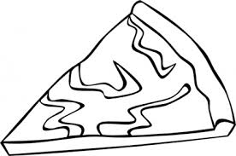

Write missing numbers in the blanks .

|  |  |  |  |  |  |  |  |  |
| --- | --- | --- | --- | --- | --- | --- | --- | --- |
| 1 |  | 3 |  | 5 |  | 7 |  | 9 |

Cross out the one that is different.

|  |  |  |  |  |
| --- | --- | --- | --- | --- |
| Macintosh HD:Users:mac_osx:Desktop:shapes: 2.png | Macintosh HD:Users:mac_osx:Desktop:shapes: 2.png | Macintosh HD:Users:mac_osx:Desktop:shapes: 2.png | Macintosh HD:Users:mac_osx:Desktop:shapes:images.png | Macintosh HD:Users:mac_osx:Desktop:shapes: 2.png |
| Macintosh HD:Users:mac_osx:Desktop:shapes:images5.jpg | Macintosh HD:Users:mac_osx:Desktop:shapes:images5.jpg |  | Macintosh HD:Users:mac_osx:Desktop:shapes:images5.jpg | Macintosh HD:Users:mac_osx:Desktop:shapes:images5.jpg |

Colour the fat object.

|  |  |
| --- | --- |
| Macintosh HD:Users:mac_osx:Desktop:shapes:images14.jpg | Macintosh HD:Users:mac_osx:Desktop:shapes:images16.jpg |

**Count and write in the box given below**.

|  |  |
| --- | --- |
|  | Macintosh HD:Users:mac_osx:Desktop:shapes:images18.pngMacintosh HD:Users:mac_osx:Desktop:shapes:images18.pngMacintosh HD:Users:mac_osx:Desktop:shapes:images18.pngMacintosh HD:Users:mac_osx:Desktop:shapes:images18.png |
|  | Macintosh HD:Users:mac_osx:Desktop:shapes:images19.jpgMacintosh HD:Users:mac_osx:Desktop:shapes:images19.jpgMacintosh HD:Users:mac_osx:Desktop:shapes:images19.jpgMacintosh HD:Users:mac_osx:Desktop:shapes:images19.jpgMacintosh HD:Users:mac_osx:Desktop:shapes:images19.jpgMacintosh HD:Users:mac_osx:Desktop:shapes:images19.jpgMacintosh HD:Users:mac_osx:Desktop:shapes:images19.jpg |
|  | Macintosh HD:Users:mac_osx:Desktop:shapes:images9.jpgMacintosh HD:Users:mac_osx:Desktop:shapes:images9.jpgMacintosh HD:Users:mac_osx:Desktop:shapes:images9.jpgMacintosh HD:Users:mac_osx:Desktop:shapes:images9.jpgMacintosh HD:Users:mac_osx:Desktop:shapes:images9.jpgMacintosh HD:Users:mac_osx:Desktop:shapes:images9.jpgMacintosh HD:Users:mac_osx:Desktop:shapes:images9.jpgMacintosh HD:Users:mac_osx:Desktop:shapes:images9.jpg |
|  | Macintosh HD:Users:mac_osx:Desktop:shapes:images7.pngMacintosh HD:Users:mac_osx:Desktop:shapes:images7.pngMacintosh HD:Users:mac_osx:Desktop:shapes:images7.pngMacintosh HD:Users:mac_osx:Desktop:shapes:images7.pngMacintosh HD:Users:mac_osx:Desktop:shapes:images7.png |
|  | Macintosh HD:Users:mac_osx:Desktop:shapes:images1.pngMacintosh HD:Users:mac_osx:Desktop:shapes:images1.pngMacintosh HD:Users:mac_osx:Desktop:shapes:images1.pngMacintosh HD:Users:mac_osx:Desktop:shapes:images1.pngMacintosh HD:Users:mac_osx:Desktop:shapes:images1.pngMacintosh HD:Users:mac_osx:Desktop:shapes:images1.pngMacintosh HD:Users:mac_osx:Desktop:shapes:images1.png |

**DAV Public School**

Sector VI, Dwarka, New Delhi

Ref.no. \_\_\_\_\_\_\_\_\_\_\_\_\_\_\_\_\_\_\_\_\_\_\_\_\_ Date \_\_\_\_\_\_\_\_\_

**Subject- EVS**

Name \_\_\_\_\_\_\_\_\_\_\_\_\_\_\_\_\_\_\_\_\_\_\_\_\_ Class- Pre School \_\_\_\_

**Draw a line from the mode of transport to the place it travels.**

**