DAV PUBLIC SCHOOL KHERA KHURD / BUDHPUR

School Website : davpskherakhurd.com , School Tel No. 01127844245 , 01127201930

SUMMER BREAK HOLIDAYS HOMEWORK

**Class-V**

**English**

1. Make a graphic organizer chart with pictures on different types of nouns .

           Group A : Countable and uncountable noun

           Group B : Common and proper noun

           Group C : Collective nouns

           Group D:  Abstract and Concrete noun

      2. Project

  Design an English magazine which should include following things:

* give a creative name to the magazine
* cover page
* a small story
* puzzles
* crossword
* cartoon strip
* advertisement
* ( you can use computer to design your magazine)

**हिंदी**

**१) भारत के  एक ऐतिहासिक स्थान ( ग्रुप के अनुसार ) का चित्र बना कर रंग भरें।  उससे संबधित निम्नलिखित  जानकारी लिखिए।**

1. **भारत के किस राज्य में स्थित है ?               ग्रुप १)  स्वर्ण मंदिर**

**ख) शहर का नाम                                         ग्रुप २)  चार मीनार**

**ग ) कब बना ?                                             ग्रुप ३) sun टेम्पल**

**घ ) किसने बनाया?                                         ग्रुप ४) अजंता - एलोरा की गुफाएँ**

**ड ) प्रमुख विशेषताएँ**

**2)   हर बच्चे का कोई न कोई सपना अवश्य  होता है।  आप भी अपने लक्ष्य के बारे में कुछ पंक्तियाँ लिख कर चित्र सहित**

**दर्शाएँ।**

**३) चित्र सहित कोई एक कहानी लिखिए।  और उससे संबधित निम्नलिखित जानकारी लिखिए---**

**क) लेखक का नाम**

**ख ) मुख्य पात्र**

**ग ) शिक्षा**

**Maths**

Project

Population of 4 Metro Politian cities/ 4 Union Territories/ 4 smallest states/4 largest states of India.

Now do the following question.

1. Find out total population of given states
2. Highest populated city/state.
3. Least Populated city/ state.
4. Find out the difference between Least and highest populated city/ state.

**Activity**

Collect the Electricity bill /Water bill/ Grocery Bill/ Telephone bill of 3 months of your home. Read it carefully and answer the following question.

1. Total units/ total expenditure in last 3 months.
2. In which month the consumption was highest.
3. In which month the consumption was minimum and by how much?
4. Write 5 ways to save energy/water/ food/ reduce the bill.

**Note:**- Group wise distribution of project and activity.

Rose/ Juice – 4 Metro Politian cities and Electricity bill

Jasmine/Jam- 4 Union Territories and Water Bill

Lotus /Sauce- 4 Smallest States and Grocery Bill

Lily /Pickle- 4 largest states and Telephone bill

**Science**

Activities would be done roll number wise in groups which are already allotted to the students.

Group 1- Rose/Jam (Rollno-1-5)

Group 2- Jasmine/Sauce(Rollno-6-10)

Group 3- Lotus/Pickle (Roll no- 11-15)

Group 4- Lily/Juice ( Roll no- 16- 20)

Activity 1- Paste pictures of any two plants which are reproduced through following ways and write the names of the plants.

1)Reproduction through leaves. Group 1- Rose/Jam (Rollno-1-5)

2) Reproduction through underground stem. Jasmine/ Sauce(Rollno-6-10)

3) ) Reproduction through roots. Group 3-Lotus/Pickle (Roll no- 11-15)

4) Reproduction through stem cutting. Group 4- Lily/ Juice( Roll no- 16- 20)

Activity -2- Paste wrappers or label of juice, pickle, jam and sauce and write the name , ingredients,

preservatives and nutritive value of the item allotted to you .

Group 1- Rose/Jam (Rollno-1-5)

Group 2-Jasmine / Sauce (Rollno-6-10)

Group 3- Lotus /Pickle (Roll no- 11-15)

Group 4- Lily/Juice ( Roll no- 16- 20)

**Social Science**

1) Paste the pictures of different types of houses and write the important features

Group A : Houses in Hilly Areas

Group B : Houses in Coastal Areas

Group C : Houses in Earthquake prone areas

Group D:  High-Rise apartments.

2) Project

Make a newsletter on Kailash Satyarthi who received Nobel Peace Prize of 2014 for working hard in the sphere of child Labour. It should include the following things:

* Creative name
* His education and life
* Pictures of his work
* His work for children
* His achievements
* His Bharat Yatra

**Sanskrit**

1. Group A पठ  के धातु रूप लट लृट में  में स्मरण कीजिए।
2. Group B बाल शब्द के रूप फाइल म लिखिए।
3. Group C किन्ही चार वाहनों के नाम संस्कृत में लिखिए और चित्र चिपकाएं।

**General Knowledge**

Q1. Collect the information about Extinct or Endangered animals. Also paste pictures of them. (Min . 5 animals)

Q2. Make a project file, on each page, Paste pictures of great personalities of the world and India(Any five each). Also write what is common among all these great people

**Music :**

Learn the following :

1. Sargam 1,2,3,4,5
2. DAV Anthem
3. Prayer teri hai zameen
4. Mantras

**Computer:**

**Make a chart on any one**

1. Memory devices of computer
2. Peripheral devices of computer

Take light green color pastel sheet and use the sheet in landscape .The border of the sheet

should be of black colour .

**Art**

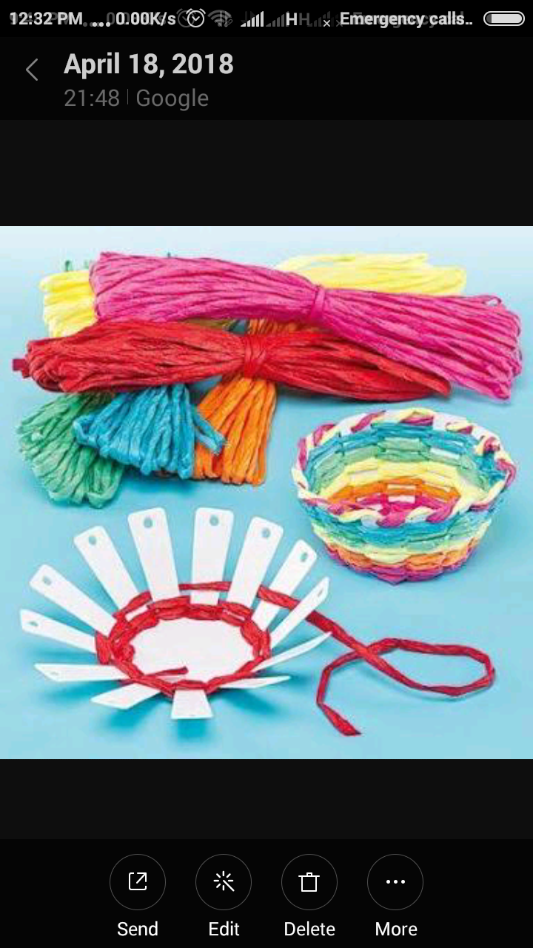Make a basket with plastic bottle and wool as shown in the picture .

**Vedpath**

1. महारानी लक्ष्मीबाई के जीवन पर लेख लिखे।

2. यज्ञ प्रार्थना स्मरण कीजिए।

3. प्रातः शाम १५ मिनट के लिए मैडिटेशन कीजिए।