**CONTENTS/ARTICLES FOR ZONAL MAGAZINE–ACTIONPLAN2022-23 DAVMMPSCGZONE-(F) & 5 SCHOOLS OF KONDAGAON**

1. SCHOOL PHOTOGRAPH – WITH NAME/MONO/AFFILICAION NO FULL DETAIL WITH ADDRESS

|  |  |  |  |
| --- | --- | --- | --- |
| SNO. | SCHOOLNAME | ADDRESS | WHOME THE SCHOOL IS SERVING |
| 1 | DAV MUKHYAMANTRI PUBLIC SCHOOL | DAV MPS,VISHRAMPURI, BLOCK- BADERAJPUR, DIST- KONDAGAON (C.G) | *It caters to the educational needs of tribal children who are primarily first generation learners.* |

2. SCHOOL HISTORY AND STRENGTH OF STUDENTS/STAFF

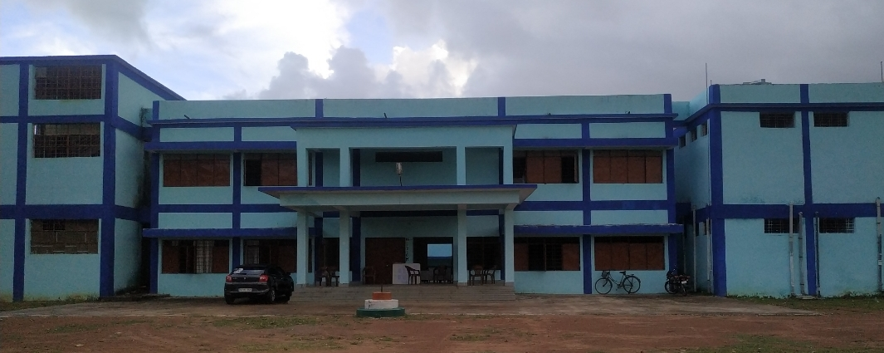

*Dav Mukhya mantri public school Vishrampuri is located at rural area in the block- Baderajpur Dist.Kondagaon.The School is in fact in the woods. Supers imposed two storied building* ***houses* 16 teachers and 486 children*.*** *The school offers B P C /M P C and commerce subject’s up to Senior Secondary level under CBSE* syllabus*. It caters to the educational needs of tribal children who are primarily first generation learners.*

*Over a period of 06 years DAVMMPS Vishrampuri has succeeded in enhancing the roll strength, regularity of pupils, garnered in establishing rappo with parents, improving results of students especially for classes X and XII drawing best wishes of local authorities and above all clinching prizes in co-curricular activities at block and district level.*

*It is my pleasure to apprise at this juncture that the school possesses well trained and experienced teaching staff, who are dedicated and determined. They ensure to bring out the latent talents of the children and channelize it in desired direction. They undergo training conducted by CBSE and Dav Nodal Centre Raipur from time to time. Thus they update their skills and capacities.*

*Apart from regular teaching-learning process, the school imparts training on 21st century skills, soft skills to the students.*

*At present the school is striving to secure accreditation from Nabet-Qci a distinguished milestone and a rare privilege extended to few schools.*

*Thus in a nutshell, DAVMMPS Vishrampuri has carved a niche in the District. KONDAGAON and surely will achieve many more benchmarks in the days to come. Certainly the students will leave their footprints over the sands of time.*

|  |  |  |
| --- | --- | --- |
| SNO. | STRENGTH | |
| STUDENT | STAFF |
| 2020-21 | 486 | 17 |

3. RESULT OF BOARD CLASSES – LAST FIVE YEARS

|  |  |  |  |  |  |
| --- | --- | --- | --- | --- | --- |
| SNO. | SESSION | X RESULT | | XII RESULT | |
| QUALITATIVE | QUANTITATIVE | QUALITATIVE | QUANTITATIVE |
| 1 | 2016-17 | 100% | 100% | 0 | 0 |
| 2 | 2017-18 | 100% | 97% | 100% | 59% |
| 3 | 2018-19 | 100% | 97% | 100% | 23% |
| 4 | 2019-20 | 96.55% | 94% | 100% | 39% |
| 5 | 2020-21 | 100% | 100% | 100%S | 100% |

4. A SPECIAL ACHIEVEMNTS/INNOVATIVE SESSION IDEAS FOR DEVELOPMENT OF STUDENTS- (*PHOTOGRAPH, COLLECTION REGARDING NEWSPAPER CUTTING REPORT). LAST FIVE YEARS

|  |  |  |  |  |
| --- | --- | --- | --- | --- |
| SNO. | SESSION | AREA | CERIFICATE | APPRECIATION |
|  |  |  |  |  |
|  |  |  |  |  |
|  |  |  |  |  |

5. SOCIAL AWARNESS ACTIVITIES - LAST FIVE YEARS (*PHOTOGRAPH, COLLECTION REGARDING NEWSPAPER CUTTING REPORT) .

|  |  |  |  |  |
| --- | --- | --- | --- | --- |
| S.NO | SESSION | DATE | THEME FOR AWARNESS CAMPAIN | APPRECIATION |
| 01 | 2019 | 02/10/2019 | SOCIAL AWERNESS ABOUT PLANTATION & CLEANLINESS | STAKE HOLDER OF SCHOOL |
| 02 | 2021 | 19/02/2021 | AWARNESS ABOUT FUTURE PLANING THROUGH CARREAR CONCILLING | DISTRICT EDUCATION OFFICER & DR.NEETA MISHRA,KONDAGAON |
| 03 | 2021 | 03/09/2021 | AGGRICULTURAL WORK SHOP | NGO,(SANGENTA ) |
| 04 | 2021 | 04/11/2021 | SCIENCE EXHIBITION | STAKE HOLDER OF SCHOOL |
| 05 | 2021 | 20/9/2021 | MEDICAL CAMP | CHIEF MEDICAL OFFICER ,VISHRAMPURI |
| 06 |  | 23/09/2021 | ELECTRICTCAL AWARNESS CAMP | CSEB, VISHRAMPURI |

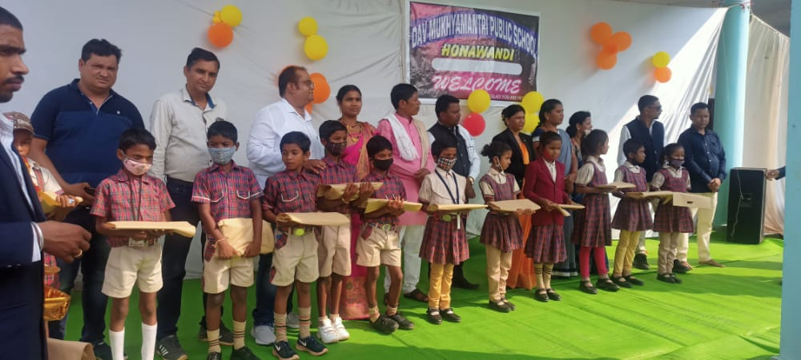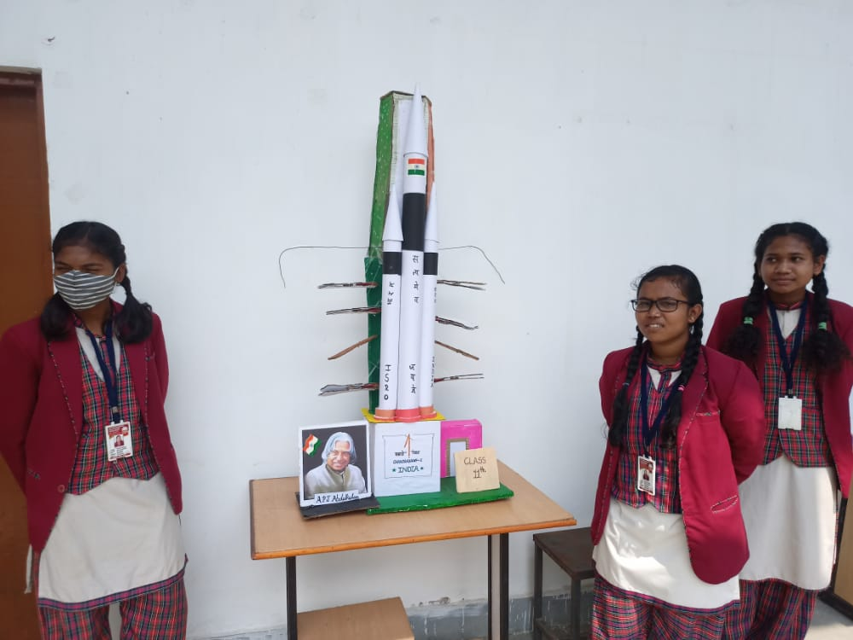

PRESENTATION FOR INNER STRENGHT

SUPPORTERS COME OUT FOR THE SOCIAL ASSISTANCE

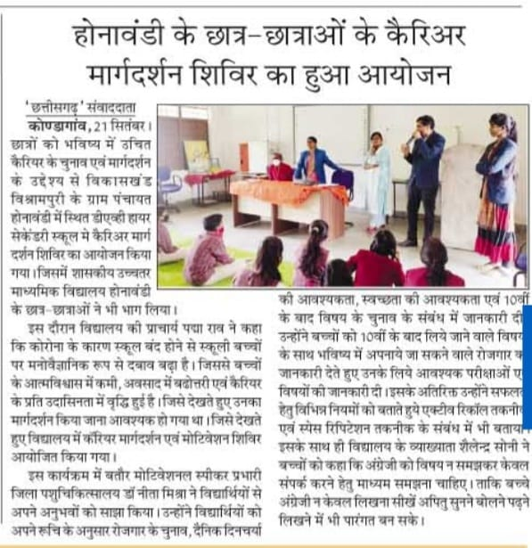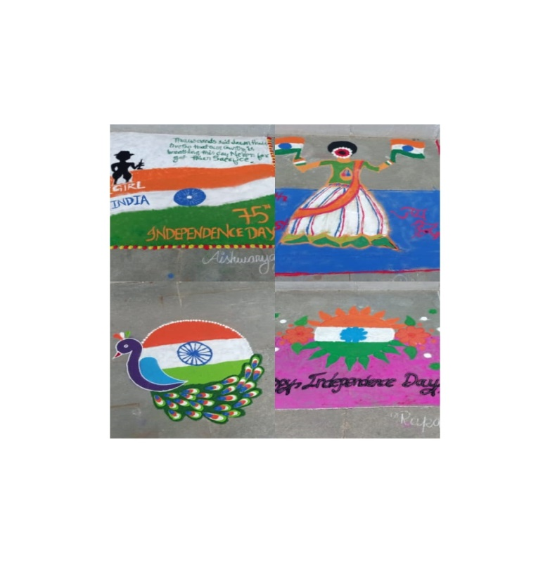

PANITION AXHIBITION BY SCHOOL

CARRER CONCELLING ORGNISED BY SCHOOL

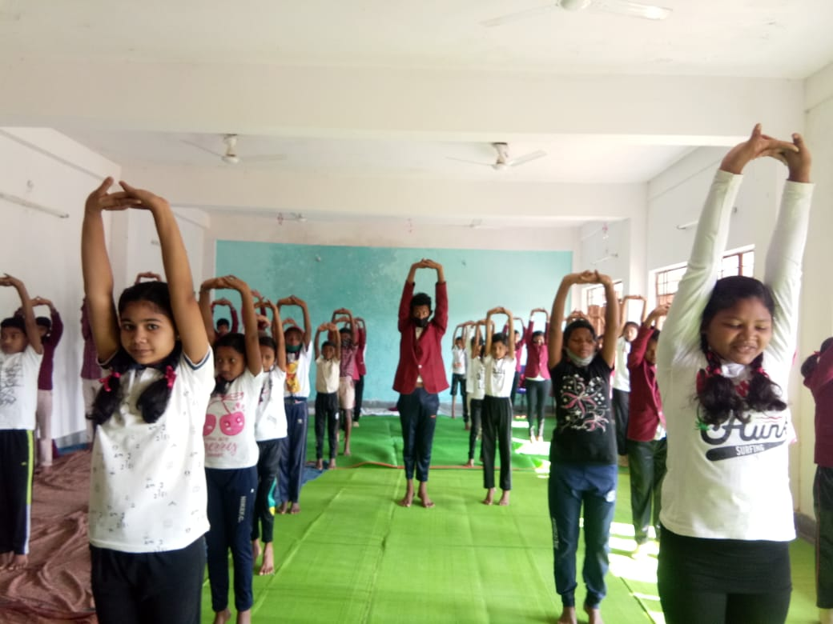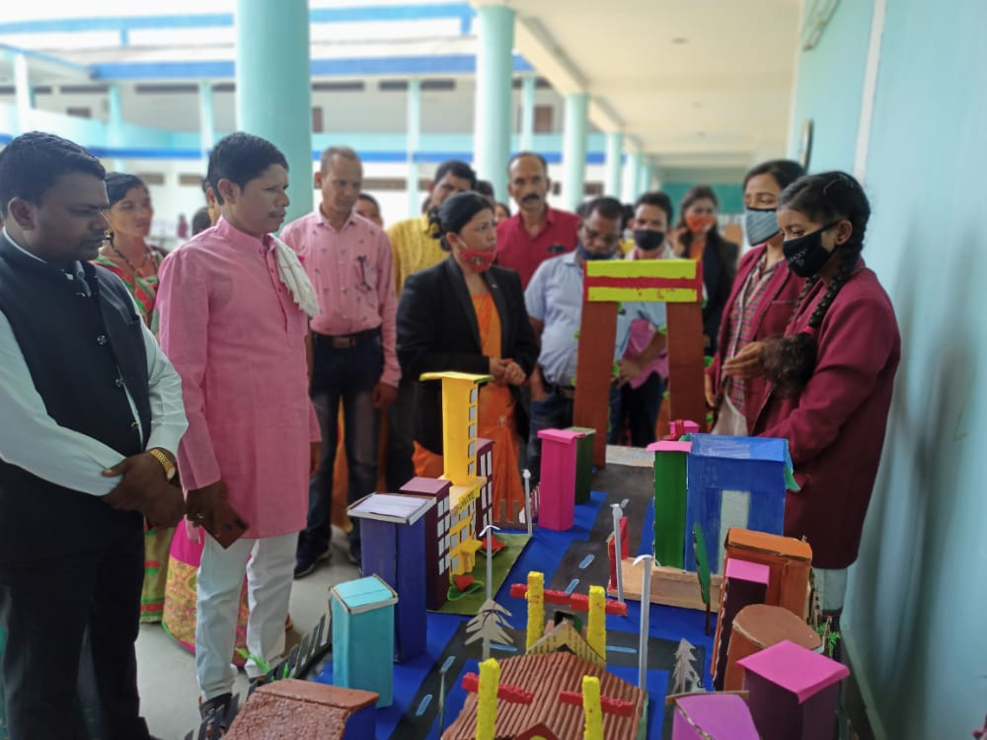

SCIENCE EXHIBITION

PHYSICAL EXERCISE ORGNISHED BY THE SCHOOL AS YOGA

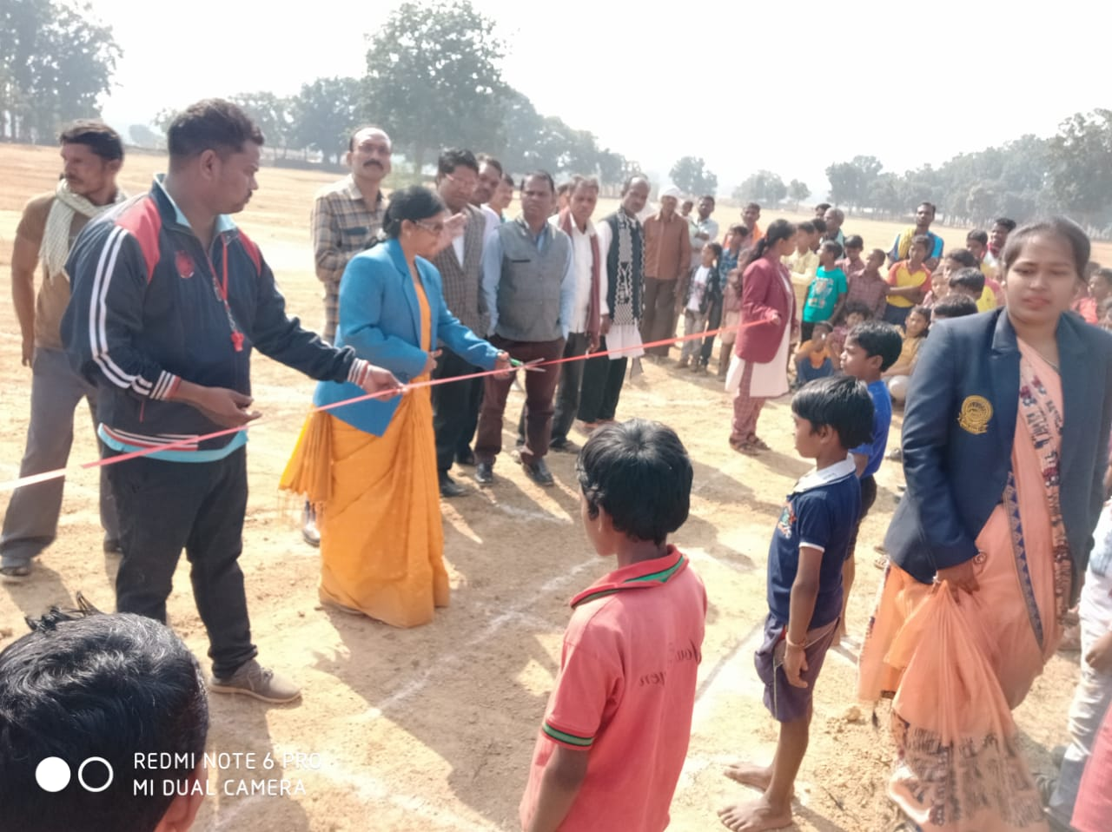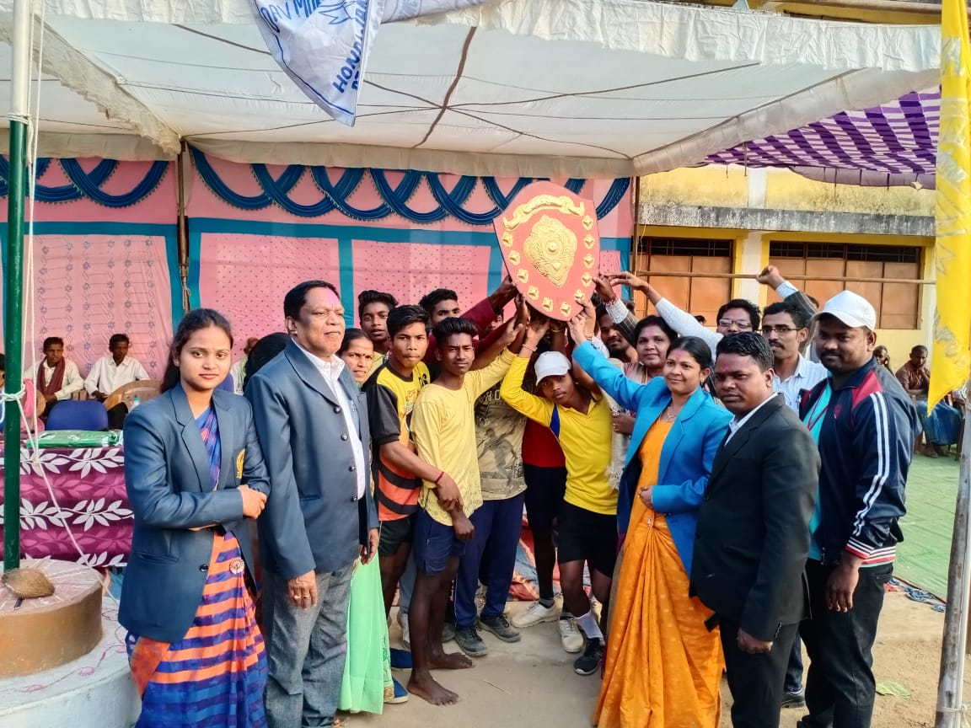

CONTESTANT WHO WINS THE 1ST POSITION

SPORTS ACTIVITES CONDUCTED BY SCHOOL

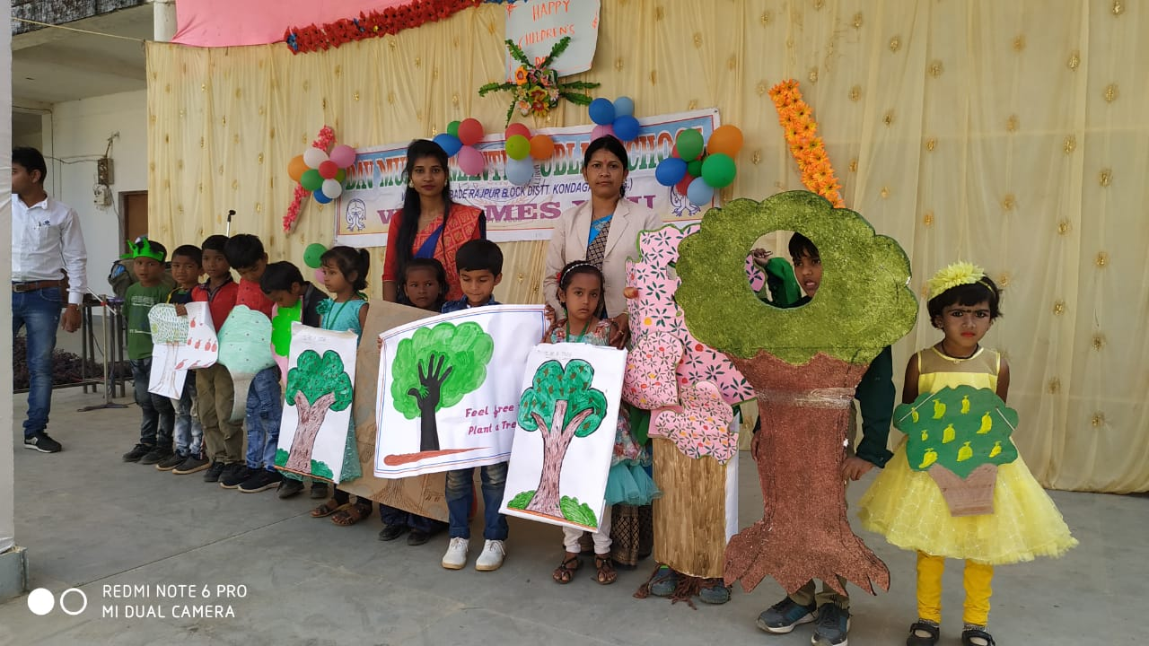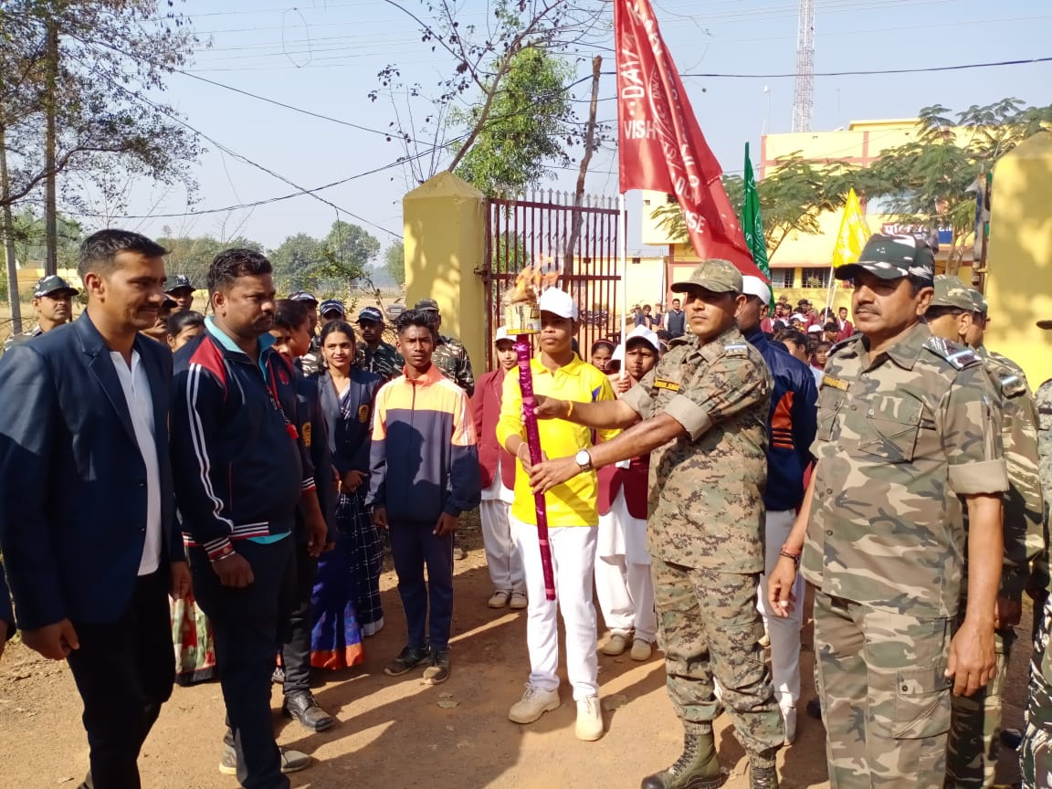

SPORTS INAUGURATION BY CRPF COMMANDENT

ENVIRONMENTAL AWARNESS

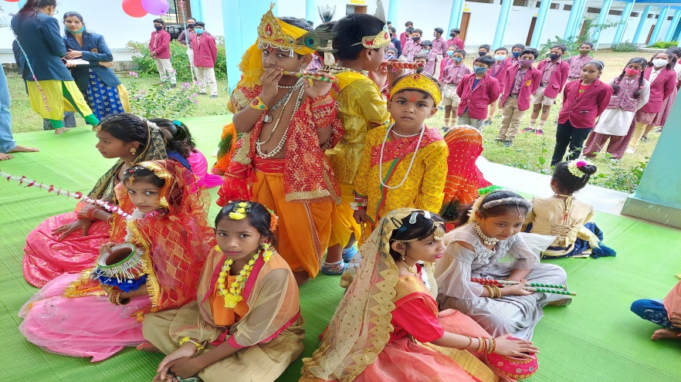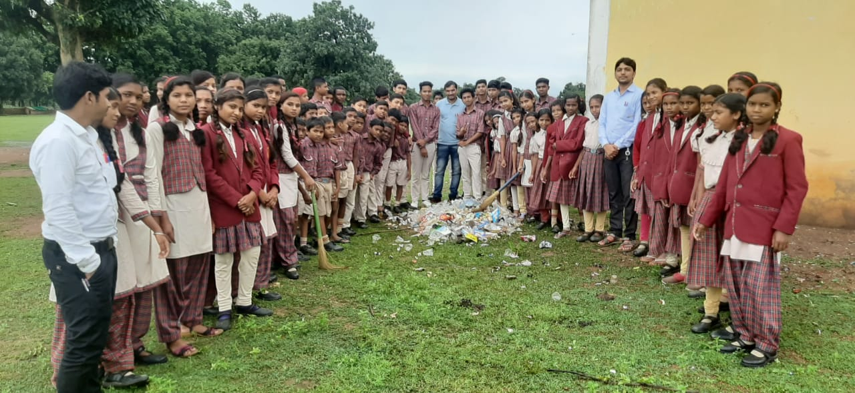

**S**