S L S D.A.V PUBLIC SCHOOL, MAUSAM VIHAR, DELHI – 110051

SUMMER HOLIDAY HOMEWORK – CLASS VI

**GENERAL INSTRUCTIONS:**

* **“Knowledge is Power”.** Encourage your child to cultivate the reading habit.
* **“A healthy mind lives in a healthy body”.** Encourage your child to go out and play because sports instil discipline, generate sporting spirits, channelize energies constructively.
* Communication skills play a pivotal role in grooming the overall personality of the children. Converse with your child preferably in English.
* Sensitize your children about the rich culture and heritage by watching different informative channels like ‘The National Geographic’, Animal Planet etc.
* Holiday homework should be done as per the instructions given on A4 size sheet. (either ruled/plain sheets)
* The child will be assessed for the neat handwriting, presentation and submission of work in time post vacation.
* Homework must be labelled properly indicating very clearly the name, class, roll no. and subject.
* Parents can be facilitator at home but the work should be done independently by the child in his/her own handwriting.

**HAVE A FUN FILLED VACATION**

**ENGLISH**

***“Without words, without writing, without learning there would be no history, there could be no concept of humanity…****.”* ***Hermann Hess***

***1. “Be sure to taste your words before you use them…”***

***These are the holidays we awaited for. Let’s be together to play and learn something. Here are some pairs of words given below which often confuse us. Let’s learn what they convey and how they are different from one another. We have done the initial one for you.***

* Practice, practise

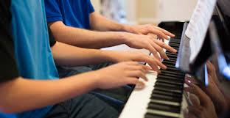

***Practice*** (work on something for perfection)-Practice makes a man perfect.

***Practise*** (Verb) - I am practicing on my violin in now a days.

* Advise/ advice
* Avenge/Revenge
* Flea/ flee
* Rain/ reign
* Pray/ prey
* Lesson / lessen
* Vain/ vein
* Waive/wave
* Access/ excess
* Soar/sour

**2. *“Learn as much as by writing as by reading…..”***

***We are going to start a story which you have to make your own by nurturing it with your thoughts and vision. Here are the some words for you use them and create the your one:***

**There was a boy who was never interested in obeying his elders. He always believed that he was right and knew everything ___________________________________________________________________________________________________ ____________________________________________________________.**

**Referral words-** advice, Holidays, respect, vacation, quibble, probe, vain, cuddle, comprehend, learning, asset

***3. Humanity is the biggest religion to follow….***

***Let’s be human and care for the environment we live in. Create a colorful poster using your creative skills on the topic “We…Today and Tomorrow-Our world, our Environment”***

***Define your theme of poster in your own words on a colorful sheet. (word Limit-120 words)***

***4. “All books can be divided into two classes: books of hour and book of time.” Ruskin Bond is a writer who belongs to the letter one. Here are some books of the author. Read one of them and write the book review using the following points given in the graphic image:***

* The Blue Umbrella
* The Cherry Tree
* School Days
* Rusty
* Getting Granny’s Glasses

***Don’t Forget***

* *In Q.1 kindly draw the referral pictures as suggested*.
* *In Q.4 on the basis of the provided graphic image form the required headings and define each of them in the word limit of maximum 50 words.*

**SCIENCE AND TECHNOLOGY**

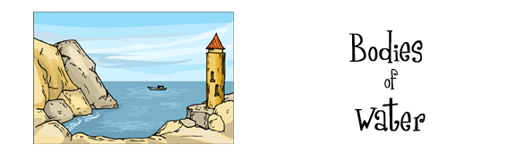

1. Rajendra Singh popularly known as “The Water Man of India” has been awarded the 2015 Stockholm Water Prize Laureate ,for his innovative water restoration efforts and improving water security in rural India.
2. Find out how he used the traditional 1000 years old method of collecting rainwater and storing it. Full credit goes to Mr. Rajendra Singh to bring water back to the driest state of India.
3. Even your small efforts can help, so this vacation ensure not to waste water and write a brief note on how you helped in water conservation?
4. Prepare any one article using only the waste material present in your house.
5. As U.N. declared this year as international year of light.
6. Design your own logo for international year of light.
7. What are the main resources to generate electricity? Why solar energy is considered as a prime resource of generating electricity in now a days? Justify your answer in about 80-100 words

**MATHEMATICS**

Here are few activities in holiday’s hw like Sudoku, Mathdoku and Rubik’s Cube which will help the learners in following ways

1. IMPROVES MEMORY
2. STIMULATES MIND
3. INCREASE CONCENTRATION
4. Find 4 tricks using vedic mathematics.
5. Explore video on you tube on “how to solve a rubik’s cube?” practice the same and gain expertise in minimum time.
6. Do at least 5 -5 sudoku and mathdoku from ht city.
7. Collect information about any one indian mathematician and write it down on a4 size sheet along with picture.
8. What is BMI? explain and show calculations of BMI of your family members.
9. Solve the given worksheets in the worksheets itself and bring holidays hw in a homemade paper bag.( worksheets attached related to FA 1)

**SOCIAL SCIENCE**

**Q1 Sources of communication in ancient and modern period**

Communication is a Latin word derived from the word commute that means to share. Communication is not just a way to share our emotions

But it is something that makes us different from other species.

1. Write the importance of means of means of communication in today’s

Context and compare it with the ancient times.

Design a Bhojpatra

Think yourself to be in ancient times when there were no means of communication . People used to write on Bhojpatra , rock edicts, walls of temples and clay tablets.

Imagine yourself to be an ancient man. Write a letter on bhojpatra, using big dried leaves inviting your friend for kite flying contest to be held at your place on the occasion of Independence day celebration.

Q2 **DIVERSITY IN INDIA**

The Indian culture is often labeled as an amalgamation of several cultures spread across the Indian subcontinent and has been influenced by a history that is several millennia old.

Compare and contrast the life style , culture, religion, custom and vegetation of one state in North and South India.

Example 1) Jammu and Kashmir

1. Rajasthan and kerela .

Q3 Values

Values are principles or standard of behavior ; one’s judgment of what is important in life , values have a major influence on person’s behavior, attitude and serve as broad guidelines in all situation.

Student will make an interesting and creative project based on “values” given below.

1. Caring 2) Senstivity towards Environment 3) Team Work.

* Collect colored or black and white newspaper articles , pictures depicting the values .
* Write a prayer , a song , stories related to these values.
* Write the Importance of values.
* Paste pictures related to these values and make your project attractive and creative.

Do all this work in A4 size sheet.

**HINDI**

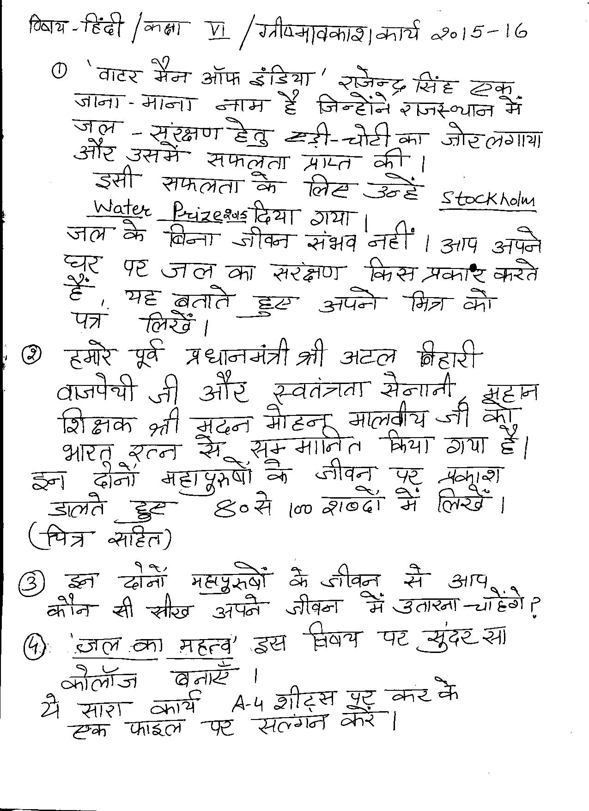

**FRENCH**

1. TROUVEZ ET REMPLISSEZ AVEC LES MEMBRES DE LA FAMILLE. (FAITES CETTE EXERCISE DANS VOTRE CAHIER DE FRANCAIS)(FIND AND FILL THE BLANKS WITH THE MEMBERS OF THE FAMILLE. DO THIS EXERCISE IN YOUR FRENCH NOTEBOOK)

* LE PERE DE VOTRE MERE ___________
* LE FILS DE VOTRE PERE ____________
* LA MERE DE VOTRE PERE ___________
* LA SOEUR DE VOTRE FRERE ___________
* LE FRERE DE VOTRE MERE ___________
* LES ENFANTS DE VOTRE TANTE __________
* LE FILS DE VOTRE GRAND MERE __________
* LA FEMME (WIFE) DE VOTRE GRAND PERE ___________

1. FAITES UN DICTIONNAIRE DES IMAGE DE VERBES EN ‘ER’(20 VERBES). CONJUGUEZ LES VERBES ET COLLEZ LES IMAGES POUR LES MEME. (MAKE A PICTURE DICTIONARY OF ‘ER’ ENDING VERBS (ANY 20 VERBS). CONJUGATE THE VERBS AND PASTE THE PICTURE FOR THE SAME. DO THIS ACTIVITY IN A SCRAP FILE)

**SANSKRIT**

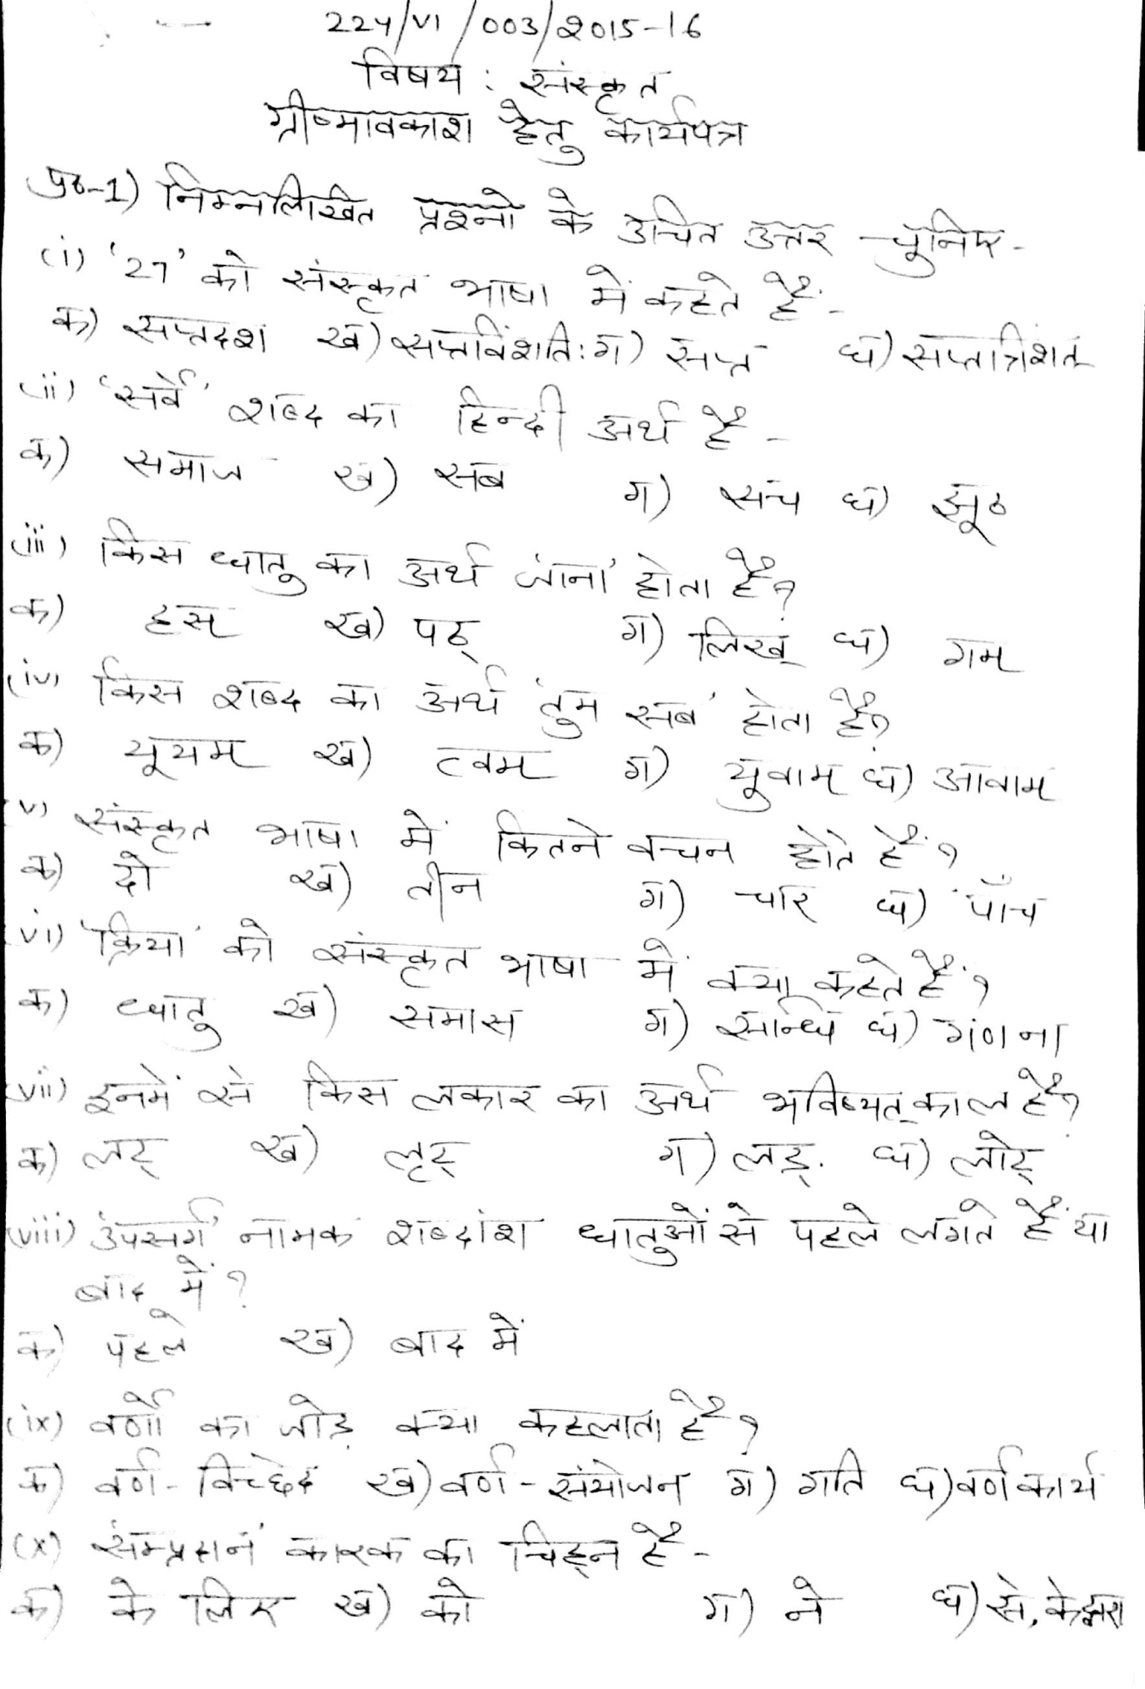

**DHARAM SHIKSHA**

